

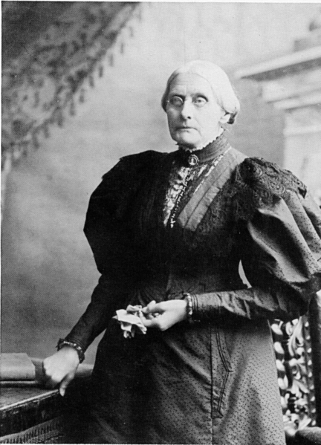

Susan B. Anthony
WE HAVE A SAY ABOUT THINGS THAT ARE IMPORTANT TO US.

UNITARIAN UNIVERSALIST ALPHABET
Please read the Overview before using this Plan.
A a From the example of Susan B. Anthony, we apply the democratic process to “guidelines for living together.”

MATERIALS: Construction Letter A with hole punched in top, yarn for necklace.
Pictures, artifacts for the letter A
Newsprint, makers for “Guidelines for Being Together”
Snack items—apples/apple juice, animal crackers

GETTING STARTED:
Welcome. After each person says his or her name, the group responds, “Welcome, (name).”
For a child who is attending for the first time this year, add name to the letters that have been posted, and make a nametag during or after the session. Leave an empty chair for the person who is not present or for someone who has not joined the group yet.

Attendance. “Attending” means being here and also means “tending to,” or “paying attention to.” We do this when we welcome each other. “Absent” means “missing,” and we miss people when they are not with us. Absences are not punitive; but acknowledgement that we miss each other when someone is not present. If a person is absent because of illness, possibly have the group make a card or pictures to be sent to the absent person.

The attendance can be noted by having each participants put a check or sticker by his or her on a “We Are Here” Chart. (Have the individuals do this rather than an adult, as their statement of being here.)

Sample We Are Here Chart
Names | Date | Date | Date | Date | Date
The Letter of the Day:
- Talk about the Letter.
- Give the Letter Necklace to a person with that initial.
- Talk about the things that the children have brought for the Letter, and/or Letter Bag.

Special space for things that have been brought for the Letter A. Talk about this special place being like an “altar” or place where important things are placed. While altars are intended for worship in many faith traditions, focus here on the special attention, not worship, for the letter items. This special place can be used every week for the special letter items. (Mention the altar table in the sanctuary, if there is an identified place as such.)

SPECIAL PERSON: Susan B. Anthony (Feb. 15, 1820-1906)
Have you ever heard about “voting”? Voting is how we elect the people who make the laws and how we choose the leaders of our congregation.

If I were going to give you ice cream OR cake, and asked which you wanted –and the whole group had to have the same thing-- we could vote. Whichever got more votes, cake or ice cream, would decide which we would have. Would you be ready to vote? But wait! What would happen if only the boys could vote? Would you girls like that? Would it be fair?

When Susan B. Anthony was alive, only men could vote! This really made her angry! She believed that women had just as much right to make decisions and laws. So she worked with many other women for over 50 years to try to change the laws so women could vote the same as men. She was even arrested and fined for voting. But when she died in 1906, there were only 4 states in the United States that allowed women to vote. And it wasn’t until 14 years after she died, or the year that she would have been 100 years old (1920), that Congress passed the law so that women could vote anywhere in the United States.

Susan B. Anthony lived in Rochester, New York, and was a member of a Unitarian church there. Some of her close friends (Elizabeth Cady Stanton, Matilda Joslyn Gage and Lucretia Mott) knew women of the Iroquois tribe of Native Americans. These Iroquois women were honored leaders in their tribe who gave Susan and her friends the courage and determination to keep working so that women would have the right to vote and be leaders in their own society.

AFFIRMATION: We have a say about things that are important to us. We call this the “democratic process.”

One way of using the democratic process is voting. We are going to use another way, called “consensus” to make our “Guidelines for Being Together”. This will help to include everyone’s ideas. Each person can give ideas about how he or she wants to be treated, followed by a list of what each person agrees to treat others. Items can be included by the teacher, if they are not mentioned by the children. After getting ideas, it might be helpful to word the guidelines in first person for easier understanding, such as:
- I want people to listen when I talk and I will listen when other people talk.
- I want to use things and play with toys, and so do others, so I will share.
- I will help keep our space clean.
- I want to feel safe and I will not hurt others.

Post the Guidelines as a reminder, ask if everyone understands them and can follow them, and read them periodically. Mention that the group will talk about these sometimes and may add other ideas.

THE LETTER A IN THE CHURCH

Altar. The altar is where special things are placed. In churches, this may be a table at the front of the room where worship services are held. Things on an altar may be candles and flowers. An altar in the group’s room could be a shelf that holds a chalice, special things that have been brought in for sharing.

A-B-C
Animals: alligator, ant, antelope, aardvark.

Body: Ankles, arms. (If the large body picture was not drawn as part of the opening session and will be drawn under Session B, add these parts then.) Examples: Arms can carry things, can give people hugs, hold things, like pets. Ankles help hold us up.

Calendar:
- Note the date of the session and any special events for the day, including birthdays.
- Note items beginning with A: April, August.
- Note events between today and the next session, including birthdays.

CLOSING: Gather around the Special Place where the things related to the letter have been placed. " We give thanks for the Letter A. We have shared and learned about special people and animals and ourselves and our church. May we leave in love and peace. Next week we will meet again. Our letter will be ____ and our leader(s) will be ____________________." Make sure that people take home things that need to go.

VARIATION FOR OLDER CHILDREN

SPECIAL PERSON:
Susan B. Anthony was angry when she could not vote. She decided to work to change the laws. With the energy from her anger, she worked for justice and fairness.

Anger. This is a feeling that we sometimes get.
- What do you do when you feel angry? What can you do if you feel angry so that you will not hurt yourself or someone else?
- Discuss how you want children to cope with anger in the session, if it occurs. (This needs to be discussed with all of the teaching team, and consistent with Religious Education Policies in your church.)

Continue discussion of the relationship between Susan B. Anthony, her friends, and the Iroquois women.

ANIMALS: Discuss the concept of “endangered species” and note animals that are on the official lists as they come up in the sessions. Take away pictures of a specific animal. What would it mean to other animals? What does the loss of a
species of animals or plants mean in the "web of the universe"?

Species are changing all of the time, including some naturally becoming extinct and new ones developing. What is the role of humans in these changes?

SPECIFIC RESOURCE
The Untold Story of the Iroquois Influence on Early Feminists: Essays by Sally Roesch Wagner, Sky Carter Press, PO Box 2135, Aberdeen, SD 57402-2135, 1996 and Postcard, "Iroquois Women," Syracuse Cultural Works, Box 6367, Syracuse, NY 13217

© Helen Zidowecki 10/2007

