

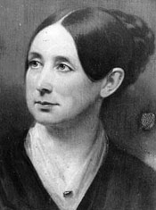
UU Historical Society web

Dorothea Dix

EVERYONE IS SPECIAL.

WE HELP MAKE THE WORLD BETTER FOR EVERYONE.

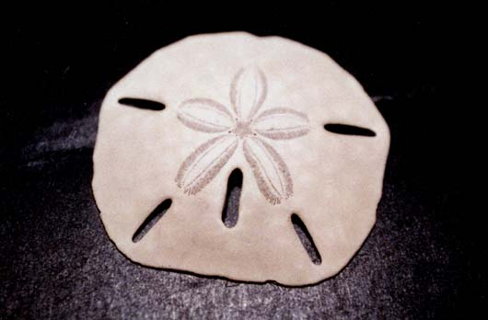

UNITARIAN UNIVERSALIST ALPHABET
Please read the Overview before using this Plan.

D d Letter D introduces Dorothea Dix and appreciating people with differing abilities.

MATERIALS: Construction paper Letter D with hole punched in top, yarn for necklace
Dollar, sand dollar
Snacks—doughnuts/doughnut holes, dates

GETTING STARTED:
Welcome. After each person says his or her name, the group responds, “Welcome, (name).” For a child who is attending for the first time this year, add name to the letters that have been posted and to the attendance sheet, and make a nametag during or after the session. Leave an empty seat for someone who is not here today or for someone who has not joined the group yet.

The Letter of the Day:
- Talk about the Letter.
- Give the Letter Necklace to a person with that initial.
- Talk about the things that the children have brought for the Letter, and/or Letter Bag.
- Put the things related to the letter in the Special Place

SPECIAL PERSON: Dorothea Dix (April 4 1802-July 18, 1887)
Dorothea Dix was born in Hampden, Maine, near Bangor. She lived in a small cabin and took care of her two younger brothers. Her father was away much of the time, sometimes preaching in small towns, and her mother was frequently sick. When she was 12 years old, she left her family and went to live with her grandmother and then with an aunt in Massachusetts.

Dorothea was able to get an education with her aunt. After she finished school, she continued learning by going to hear people talk and by going to the library to read. She taught school during the day, then opened a school for children who were too poor to go to school. She called her school "The Hope." She sometimes took care of the children of William Ellery Channing, a famous Unitarian minister.

Dorothea was teaching Sunday School in a jail for women. After the class, she wanted to see how the people in jail were treated. She found some women in a cold room. They had some problems or conditions that needed special care. Dorothea was upset by the treatment the women were receiving, so she went to the library to read whatever was written about their care. Then she visited other jails in Massachusetts. She wrote a report that was written by the legislators, or the people who make the laws and decide how tax money will be used. Her concerns were printed in the newspapers. Finally, money was made available for treatment.

A story about Dorothy tells how she was looking at a sand dollar one day. The sand dollar is a small sea anima found on beaches. The design on the shell looks like 5 tear drops. She thought of these as tears for the sadness when people do not have enough to eat or clothing, or the right care if they have special needs. But when the sand dollar is opened after the animal has died, there are 5 small pieces of shell that look like doves. For Dorothea, these doves were hope that all of us can bring when we try to understand people’s needs and to help meet those needs.

(Show a picture of sand dollar, or real sand dollars. These were named for the dollars that are coins used for money, rather than paper dollars.)

AFFIRMATION We help make the world better for everyone.

Dorothea was concerned about making sure that people had their needs met. She realized that all of us have different abilities.

All of us are different—which is a D word, different. Some of us can jump far, some of us cannot, and some cannot jump at all. Some people have difficulty or trouble doing things that we usually just expect that everyone can do.
Have children take on various problems for a brief period, then talk about what we can do to help a person with a particular problem. Examples:
- Cover ears and try to hear what the teacher says. (Help: Speak so that a person can see our lips clearly. Do not need to shout. Talk about hearing aids and sign language. Does the church have any way of helping people with hearing problems, such as seating closer to the front available, someone to sign the services, or special speaker system with aids?

- Move across the room without using a leg. (Help: chair with wheels, carrying things for the person. How would a person who uses a wheel chair or crutches get to all parts of the church building?)

- Move across the room with eyes closed. (Help: Have person put with the eyes closed hold onto another person's arm and follow that person. Discuss braille. If church has braille or large print hymnals, show them to the group.)

THE LETTER D AROUND THE CHURCH

Doors: Doors can be inviting or intimidating. Discuss the concept of doors as keeping people out or in. One of the hardest places for people to get through are doors or doorways. Are there doors that the children cannot open? What does it feel like not to be able to open a door?
Look at or talk about different doors in the church. Which doors are open, and which are closed, when and why?

Disability symbol. Talk about the sign for accessibility regarding entrances, parking areas, and ramps.

A-B-C
Animals: deer, dinosaur, dog, dolphins, donkey, dragon, dragon fly, duck.
Dogs help people in special ways, such as seeing eye and ear dogs (Information is available from veterinarians and Animal Shelters.)

Body parts:

Calendar: December, day and date
- Note the date of the session and any special events for the day, including birthdays.
- Note items beginning with that letter
- Note events between today and the next session.

CLOSING: Gather around the Special Place where the things related to the letter have been placed. " We give thanks for the Letter D. We have shared and learned about special people and animals and ourselves and our church. May we leave in love and peace. Next week we will meet again. Our letter will be ____ and our leader(s) will be ____________________." Make sure that people take home things that need to go.

VARIATIONS FOR OLDER CHILDREN

Introduce material from the Accessibilities Committee of the Unitarian Universalist Association (25 Beacon Street, Boston, MA 02108, 617-742-2100, x 460), such as the pamphlet "What do I say? What do I do?" Talk about and possibly have the group reword the guidelines:
- Show the person the same respect you wish for yourself.
- Talk directly to the person; don't speak only to others who are with the person, as if the person is not there. (This is similar to having someone ask the parent for the child's opinion when the child can answer.)
- Be aware of barriers -- buildings, attitudes and communication -- that prevent people from full participation.
- Ask the person the best way for you to help.
- Understanding that a disability is a natural part of human experience, and is not the same thing as being sick.
- Focus on things you have in common rather than on differences.
How do we talk about people? Regardless of ability, focus on the person first, then list the trait, if necessary. Such as:
- Susan is a good athlete (rather than Susan is an athletic person).
- Susan has a hearing problem (rather than Susan is hearing impaired).
- Bobby is a child with special needs (rather than Bobby is a special-needs child).
- Jim has special talents (rather then Jim is a gifted child).
Naming the person first focuses on the person, who has specific attributes.

ADDITIONAL REFERENCES
That All May Worship: An Interfaith Welcome to People With Disabilities, Ginny Thornburg, Editor, National Organization on Disability, 1996.

Welcoming Children With Special Needs: A Guidebook for Faith Communities, Sally Patton, UUA, 2004.

Women of Maine by Lee Agger, Guy Gannett Publishing Co., 1982.

© Helen Zidowecki, 10/2007

