

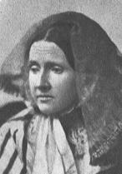
UU Historical Society web

Julia Ward Howe

WE HELP MAKE THE WORLD BETTER FOR EVERYONE.

UNITARIAN UNIVERSALIST ALPHABET

Please read the Overview before using this Plan.

H h Letter H introduces Julia Ward Howe, and Mother's Peace Day.

MATERIALS: Construction paper with hole punched in top, yarn for necklace
Snacks—Honey, such as on crackers, ham, hamburgers

GETTING STARTED:
Welcome. After each person says his or her name, the group responds, “Welcome, (name).” For a child who is attending for the first time this year, add name to the letters that have been posted and to the attendance sheet, and make a nametag during or after the session. Leave an empty chair for someone who is not present or for someone who has not joined the group yet.

The Letter of the Day:
- Talk about the Letter.
- Give the Letter necklace to a person with that initial.
- Talk about the things that the children have brought for the Letter, and/or Letter grab bag.

SPECIAL PERSON: Julia Ward Howe (May 27, 1819-October 17,1910). Tell the group that the story is being told as if Julia Ward Howe were talking. This is a compilation of her story from various sources.
Do you know what we celebrate on the second Sunday of May? Mother's Day. I would like to tell you how it got started.

When my husband and I were visiting Washington in 1861, different parts of the country were fighting against each other. (Clara Barton was getting supplies and treatment for the soldiers in this war.) We saw soldiers who were singing, even though they were discouraged. My minister (James Freeman Clarke) suggested that I write words to the tune that they were singing, to encourage them. One night, I suddenly woke up and wrote a poem for them. Singing gave them hope. The song was called "The Battle Hymn of the Republic." But the sight of the soldiers made me sad.

In 1870, a terrible war broke out in Europe called the Franco-Prussian War. It was just horrible for me, because I remembered the war here in this country that we had just gone through. I believed that there are other ways to solve problems than killing people. I thought that mothers have the responsibility to try to get the leaders (who at that time were all men) to use peaceful ways to settle conflicts.

I wrote a paper calling for the women of the world to work for peace. I had it translated into different languages so that people could read it in French, Spanish, Italian, German and Swedish. Then I went to London to organize a Women's Peace Congress. I wanted to speak at the peace meetings in London and Paris, but the men who ran the organizations said I couldn't give any speeches because I was ONLY a woman!

But I didn't give up. I rented a meeting hall and held my own meetings. Not many people came, but it was a start. When I returned to the United States, I started a festival which I called "Mothers' Day," a special day when the women all over the world would speak out for peace. I choose June 2 as the date for Mothers' Day, because the weather would be nice for holding rallies outdoors. For many years after that, June 2 was celebrated as a day for peace in Boston, where I lived.

In 1906, when I was 85 years old, a woman named Anna Jarvis proposed that Mothers Day be celebrated on the second Sunday in May, and it has been for many years. But now I understand that Unitarian Universalist churches are bringing back my idea of Mothers' Day for Peace. We all need to work for peace now, more than ever.

You know, I think that my favorite word is hope. All of my life I have been bringing hope to people, like to the soldiers with the song. In starting the Mothers Peace Day, I was hoping that people would really work for peace.

Remember me as someone who brings hopes for peace.

AFFIRMATION: We help make the world better for everyone.

Discuss peace signs, like doves, cranes from Japan.

THE LETTER H IN THE CHURCH

Hands: Samuel Howe, husband of Julia Ward Howe, was a well-known doctor. He was the director of the Perkins School for the Blind. He developed a way for people who were blind and could not hear to communicate with feeling through the fingers and hands. It is called American Sign Language (ASL).
Have someone discuss communications with hands for people who cannot hear, and possibly demonstrate the use of American Sign Language (ASL). Invite someone to explain and demonstrate and possibly teach some simple signs.

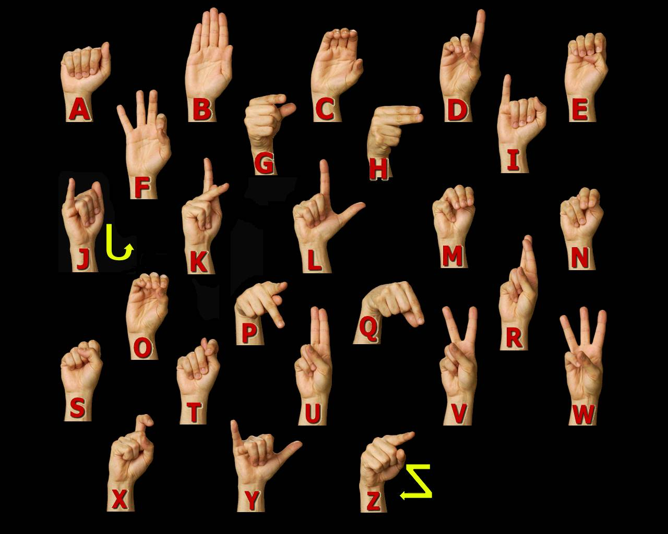

A-B-C
Animals: hippopotamus, horse

Body (add to Body Picture): hair, hand, head, heart, heel, hip
(See hand under Letter H. If sign language was not discussed there, it can be part of this session.)

Calendar: Holiday--Halloween; talk about holidays as special celebrations, which can be religious, traditional, political.
- Note the date of the session and any special events for the day, including birthdays.
- Note items beginning with that letter
- Note events between today and the next session.

CLOSING: Gather around the Special Place where the things related to the letter have been placed. "We give thanks for the Letter H. We have shared and learned about special people and animals and ourselves and our church. May we leave in love and peace. Next week we will meet again. Our letter will be ____ and our leader(s) will be ____________________." Make sure that people take home things that need to go.

==================================

VARIATIONS FOR OLDER CHILDREN

Talk about current or recent areas of fighting that they may have seen on television. Point these areas out on the globe.

Discuss ways to work for peace, including having someone in the church who has been involved with peace movements, or who has participated in a war, to speak with the group. Can we always have peace? Is there ever a time when war is appropriate?

There are numerous peace organizations, including the Unitarian Universalist Peace Fellowship (6512 Warren Avenue, Edina, MN 55439; 612-941-3508 or check UUA Directory for latest information)

© Helen Zidowecki, 10/2007

