

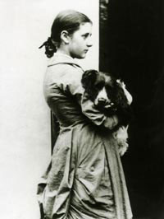
Beatrix, age 14, with pet

Beatrix Potter
WE HELP TAKE CARE OF OUR WORLD.

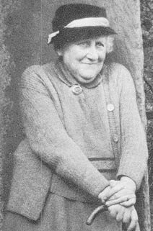
From The Magic Years of Beatrix Potter, by Margret Lane, 1978

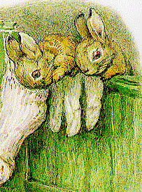

From Beatrix Potter: 1866-1943: The Artist and Her World, Judy Taylor, 1987
UNITARIAN UNIVERSALIST ALPHABET
Please read the Overview before using this Plan.

P P Letter P introduces Beatrix Potter and the care and blessing of pets.

MATERIALS: Construction paper with hole punched in top, yarn for necklace
If you are focusing on pets, items for the pet care grab bag.
Planning: Ask children to bring pictures of pets
Snacks—Peanutbutter, peanuts, pineapple, popcorn (Note concern about allergies with the peanuts.)

GETTING STARTED:
Welcome. After each person says his or her name, the group responds, “Welcome, (name).” For a child who is attending for the first time this year, add name to the letters that have been posted and to the attendance sheet, and make a nametag during or after the session. Leave an empty chair for someone who is not present or for someone who has not joined the group yet.

The Letter of the Day:
- Talk about the Letter.
- Give the Letter necklace to a person with that initial.
- Talk about the things that the children have brought for the Letter, and/or Letter grab bag.

SPECIAL PERSON: Beatrix Potter (July 28, 1866-1943)

Beatrix Potter was actually Helen Breatrix Potter, which was also her mother’s name. So she was called by her middle name, Beatrix, rather than Helen. (Does anyone in the group have the same name as their parent? Is anyone in the group called by a middle name instead of the first name?)

When Beatrix was growing up she did not go to school with other children. She was taught at home. She learned reading and writing and arithmetic, geography (study of the world), and how to speak German and French. She loved to draw and paint, and once had a special teacher to give her art lessons. Beatrix Potter especially liked drawing flowers and mushrooms and butterflies, and all the wild animals in the woods and fields and pond.

Beatrix had a younger brother. Together they tamed wild rabbits, kept a bat in a bird cage, and mice in wire boxes. They were nature lovers, and they never hurt any living thing. The farmyard dogs, kittens, ducks and pigs they saw on their vacations in the country were their friends, too. Most of the animals in her stories were real, but she made up their adventures. Beatrix Potter's pets were often her only playmates. She did not have other children to play with, and saw her brother only when he came home from boarding school on holidays.

Beatrix Potter started sending letters with pictures and stories about animals to a child who was sick. These stories were really about animals that were her pets -- Peter Rabbit, Benjamin Bunny, and her tame hedgehog, Mrs. Tiggy-Winkle. She told the stories of Peter Rabbit and all his troubles in Mr. McGregor's garden. While she was writing the stories, she drew pictures. A few years later, the stories and pictures were made into a book. Beatrix Potter began to write other stories for boys and girls.

Beatrix Potter was a Unitarian. She lived in England. She liked meeting some of her father's and grandmother's Unitarian friends. We remember her for her stories for children and her love nature and her pets.

AFFIRMATION: We help take care of our world.

Pictures: Talk about different kinds of pictures, including photographs. If children brought pictures of their pets, take time to talk about the pets, including names. Take time to tell stories about pets and their special meaning.

Pets. Have a grab bag of things that are used to take care of pets, including dishes, grooming items, food.

Puppets--Make puppets from:
STICKS-Cut out pictures of animals and glue to Popsicle sticks so that the child can hold the stick.
SOCKS -- tape or sew on yarn for hair, color eyes with markers
Have the pet puppets talk about the care that they need: proper food, clean water, safe place to get exercise, place to sleep, gentle handling.

THE LETTER P IN THE CHURCH

Piano—Is there is a piano in the church facilities? If a piano is available, show how it works.

A-B-C
Animals: pony, pig, pigeon, peacock, panther

Body:

Calendar:
- Note the date of the session and any special events for the day, including birthdays.
- Note items beginning with that letter
- Note events between today and the next session.

CLOSING: Gather around the Special Place where the things related to the letter have been placed. "For the Letter P we give thanks. We have shared and learned about special people and animals and ourselves and our church. May we leave in love and peace. Next week we will meet again. Our letter will be ____ and our leader(s) will be ____________________." Make sure that people take home things that need to go.

===================================

VARIATIONS FOR OLDER CHILDREN

Pet Blessing. Children can plan the blessing by asking the minister or another person to do the blessing, arrange the time and location for the blessing, put a notice in the church newsletter and other public places. The focus of the blessing is recognition that the pets are special, rather than having any special effect on the pet.

Pets: Collect food as donation to the local shelter. This can be done as part of a Pet Blessing (Donation for the blessing is a can of food, for example) or as a separate event. If the children collect the food, try to have the children, or at least a representative, take the food to the shelter. Or have someone from the shelter visit the group to accept the donations.

© Helen Zidowecki, 10/2007

