

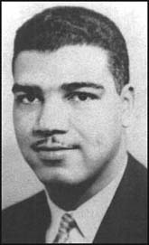

WhitneyYoung
WE ARE FAIR AND KIND TO EVERYONE

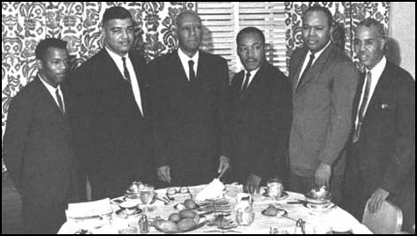
UNITARIAN UNIVERSALIST ALPHABET
Please read the Overview before using this Plan.

Y y Letter Y introduces the contributions of Whitney Young, and the youth in the congregation.

MATERIALS: Construction paper Letter with hole punched in top, yarn for necklace
Snacks—Yogurt, Yams

GETTING STARTED:
Welcome. After each person says his or her name, the group responds, “Welcome, (name).” For a child who is attending for the first time this year, add name to the letters that have been posted and to the attendance sheet, and make a nametag during or after the session. Leave an empty chair for someone who is not present or for someone who has not joined the group yet.

The Letter of the Day:
- Talk about the Letter.
- Give the Letter Necklace to a person with that initial.
- Talk about the things that the children have brought for the Letter, and/or Letter Bag.
- Put the things related to the letter in the Special Place

SPECIAL PERSON: Whitney Young (July 31, 1921-March 11, 1971)
Whitney Young was born in Kentucky. His father was a teacher and principal of the Lincoln Institute, and his mother became the first black woman to run a post office. But there was still a law that said that black people could not eat at restaurants with white people, and that black people had to sit in special places in public, like at a theater. The law made Whitney angry, but his father said, "Don't get angry. Get smart!"

Whitney was on the high school basketball team. Returning from a game that they had won, the team stopped at a restaurant, but Whitney was not allowed in because he was black. When he got home, he told his father about this. Whitney said that he hated the restaurant owner, who was white. His father told him that hate really hurts the person who hates. If someone hates you, that is his or her problem, but if you hate back, it is your problem.

Whitney worked to make things better for blacks through the National Association for the Advancement of Colored People. (See Ovington.) Whitney became the leader of the National Urban League, a group that creates jobs for blacks. He met with managers of companies to get equal rights for blacks, and he helped raise money for schools, businesses and better housing for blacks. Several US presidents discussed the problems of black people with Whitney.

Whitney Young was a member of the Atlanta (Georgia) and White Plains (New York) Unitarian Universalist Churches, and was on the board of the Unitarian Universalist Service Committee (See Session S, Schweitzer).

AFFIRMATION: We are fair and kind to everyone.

You: When have you felt that things have not been fair? What have you done about it?

THE LETTER Y IN THE CHURCH

Youth: Have some of the youth (grades 7-12) meet with the group for a joint activity. Invite youth to tell what Unitarian Universalism means to them. Have youth talk about other activities, such as conferences and youth group.

A-B-C
Animals: Yak

Body:

Calendar: Year (like the change of the date)
- Note the date of the session and any special events for the day, including birthdays.
- Note items beginning with that letter
- Note events between today and the next session.

CLOSING: Gather around the Special Place where the things related to the letter have been placed. "We give thanks for the Letter Y. We have shared and learned about special people and animals and ourselves and our church. May we leave in love and peace. Next week we will meet again. Our letter will be ____ and our leader(s) will be ____________________." Make sure that people take home things that need to go.

© Helen Zidowecki, 10/2007

