ADVENT CALENDAR ACTIVITY  Each day, take a paper with a symbol on it. The right part of the “tag” tells about the symbol, and the left part has an activity. You can attach the tag to the Advent Calendar Sheet or put a hole in the top, attach string or yarn, and hang it up. The activities are designed to be done with minimal expense. | ADVENT CALENDAR  Getting Ready for Christmas……………  A symbol a day  To help the Faith, Hope, Love, Joy  Of the Season be there for you each day.  And may you have a big dose of Patience in the general confusion of the Holidays. | ADVENT CALENDAR Advent is a time to think about the meaning of the Christmas season. Advent calendars started in Germany and Scandinavia. They have pictures of a Christmas scene, or of the manger scene. There is a window to be opened each day up to Christmas Day.
ANGEL ACTIVITIES  <>Sing carols about angels:  “Angels from the Realms of Glory”  “Hark! The Herald Angels Sing”  “Angels We Have Heard on High” (#231 in Hymnal)  "It Came Upon the Midnight Clear" (#244 in Hymnal) |  | ANGELS Angels are mentioned throughout the Bible as protective guardians and messengers from God. They appeared to the shepherds to tell them about the birth of Jesus. Angels are favorite decorations on cards and tops of Christmas trees.  The message of the angels at Christmas is joy. There are also stories of people helping other people, and this help being credited to “an angel.”
ANIMAL ACTIVITY  <>Attach grass or hay to this tag.  <>Sing “Away in a Manger,”  “Jesus Our Brother” (Animal Carol) (#243 in Hymnal)  “Gather ‘Round the Manger” (#229 in Hymnal)  <>Have animal crackers for snack, talking about which animals were in the story. | 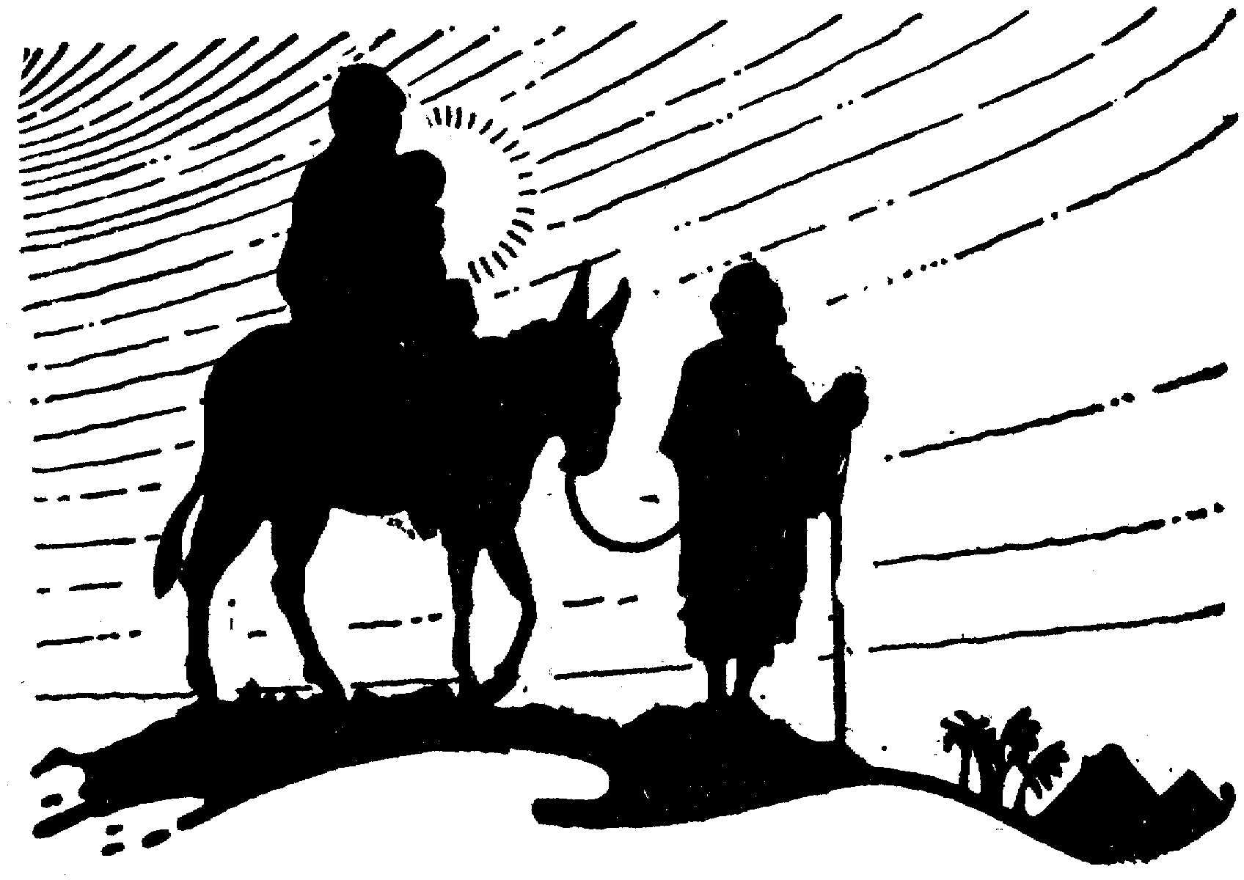 | ANIMALS Jesus was born in a stable or barn because his family could not find a room in an inn or hotel. The story says that Jesus first bed was the manger, or eating trough that the animals used. The manger was filled with hay that was soft and warm.  Mary rode a donkey on the way from Nazareth to Bethlehem before Jesus was born. And Mary and the baby Jesus rode a donkey as they escaped from King Herod, who was looking for Jesus.

BELL ACTIVITY  <>To make a bell, take a paper cup and yarn twice the length of the cup.  --Tape/glue a bead, button, or shell on one end of the yarn for the “clapper.” Tie a knot in the yarn above the clapper.  --Turn cup upside down. Put yarn above knot up through a small hole in the bottom of the cup. Tie knot in yarn. Use the yarn above the cup to hang the bell.  <>Sing “I Heard the Bells on Christmas Day” (#240 in Hymnal) Words are by Henry Wadsworth Longfellow, a Unitarian. | 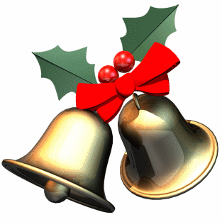 | BELLS Ringing of bells at Christmastime is from pagan mid-winter celebrations. When the earth was cold and the sun was dying, evil spirits were thought to be powerful. One of the ways to drive them off was by making a great deal of noise. On Christmas Eve in medieval times, the bells warned the devil of the birth of Jesus. For an hour before midnight, the bells sounded sad. Then, at midnight, they sounded happy to announce the death of evil and the birth of Jesus. In Scandinavia, bells signal the end of work and the beginning of festivity.
CANDLE ACTIVITY  <>Make candles by melting old wax into milk cartons or margarine containers, adding wicks. If the wax has been collected throughout the year, melting and remolding the wax is a way of getting ready for the new year.  <>Wrap toilet paper or paper towel rolls in colored paper, or paint and add glitter. Make a paper flame to tape onto the top.  <>Light a candle to remember part of your family who is not here for Christmas.  <>Sing “Bring a Torch, Jeannette, Isabella” (#233 in Hymnal) | 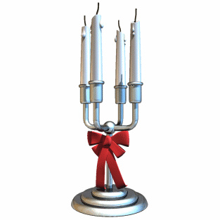 | CANDLES The light from the candle and bonfires imitated the sun, which is scarce in northern areas in winter.  Legend says that lighted candles in windows guide Jesus as he wanders through the streets of the world seeking shelter on Christmas Eve. An old German belief was that Mary, Jesus’ mother, and angels passed over the world on Christmas Eve, and candles showed where they could come in and eat.  The candle at Christmas shows that Jesus was the “light of the world,” and lived a life of love for everyone.
CANDY CANE ACTIVITY  <>Enjoy a candy cane. |  | CANDY CANES A candy maker in Indiana made the candy cane to incorporate symbols of the birth, ministry and death of Jesus.  <>The white is the goodness of Jesus, and the hardness of the candy is the firmness of the promises of God.  <>The shape is the letter J for Jesus, and also represents the staff of the shepherds to help sheep in rough places.  <>The red is for the blood, because Jesus later died for his beliefs and teachings.

CARD ACTIVITIES  <>Make a card for someone you have not seen for awhile. Send the card or hang it to remember him or her.  <>Look carefully at the cards that come to your house. What do the words say? What pictures are there? Think about the people who have sent them.  <>Save cards to be used for decorations next year.  <>Have a card swap. Each person brings a card, unsigned, in an envelope. Pass around a basket with the cards and each person take one. Everyone opens their card and talks about the picture and the message. | 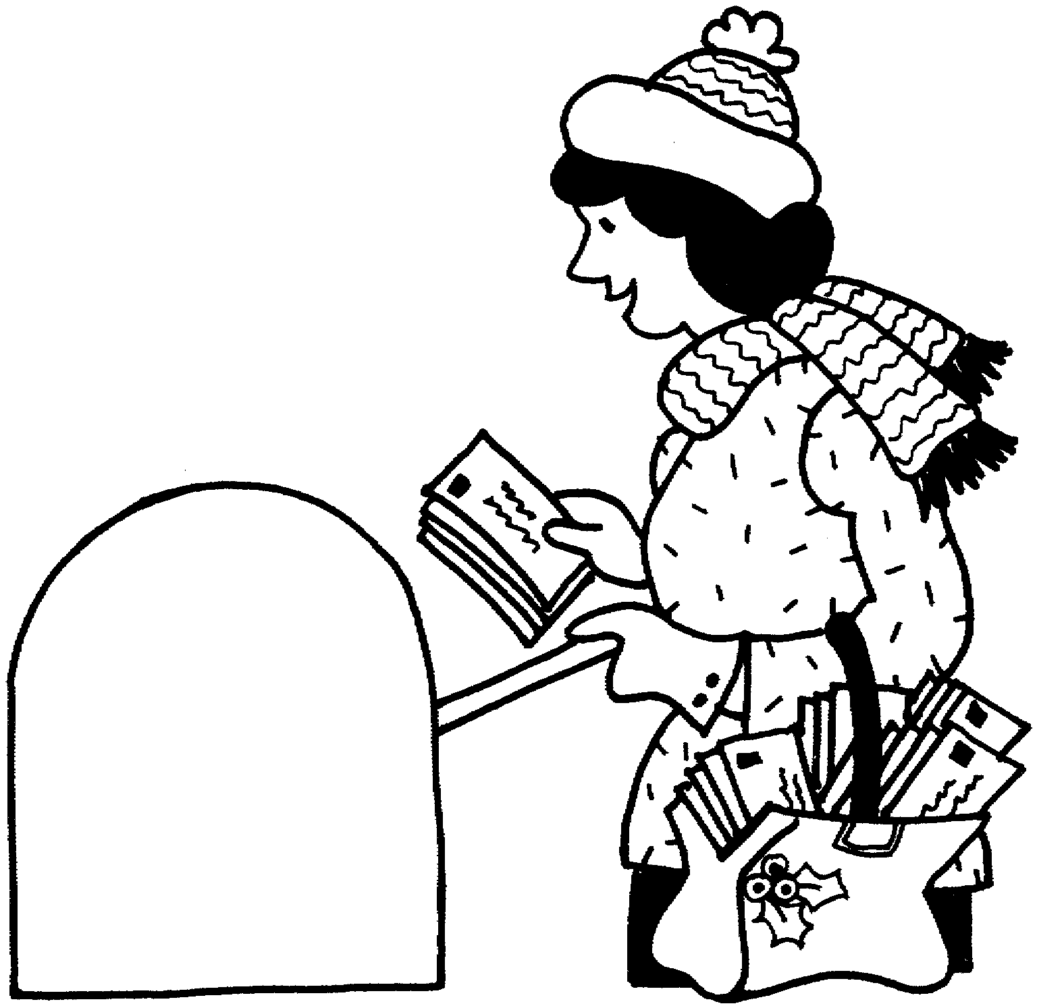 | CARDS The first Christmas card was made and sold in London in 1843 by John Calcott Hosley, an artist. The card had a picture of a family dinner and “Merry Christmas and Happy New Year to You” on a postcard. The first card in American was produced by Louis Prang in Roxbury, Massachusetts in 1875. As cards travel around the world, they link friends and nations in celebration. Cards are displayed as Christmas decorations. Special cards are saved to remember friends. What would John Hosley say about “cards” being sent electronically?
CAROLS  <>How many carols can you name or sing?  <>Some of the carols written by Unitarians or Universalists are:  "I Heard the Bells on Christmas Day" (Henry Wadsworth Longfellow, #244 in Hymnal)  "It Came Upon the Midnight Clear" (Edmund Hamilton Sears, #240 in Hymnal)  "Jingle Bells" | 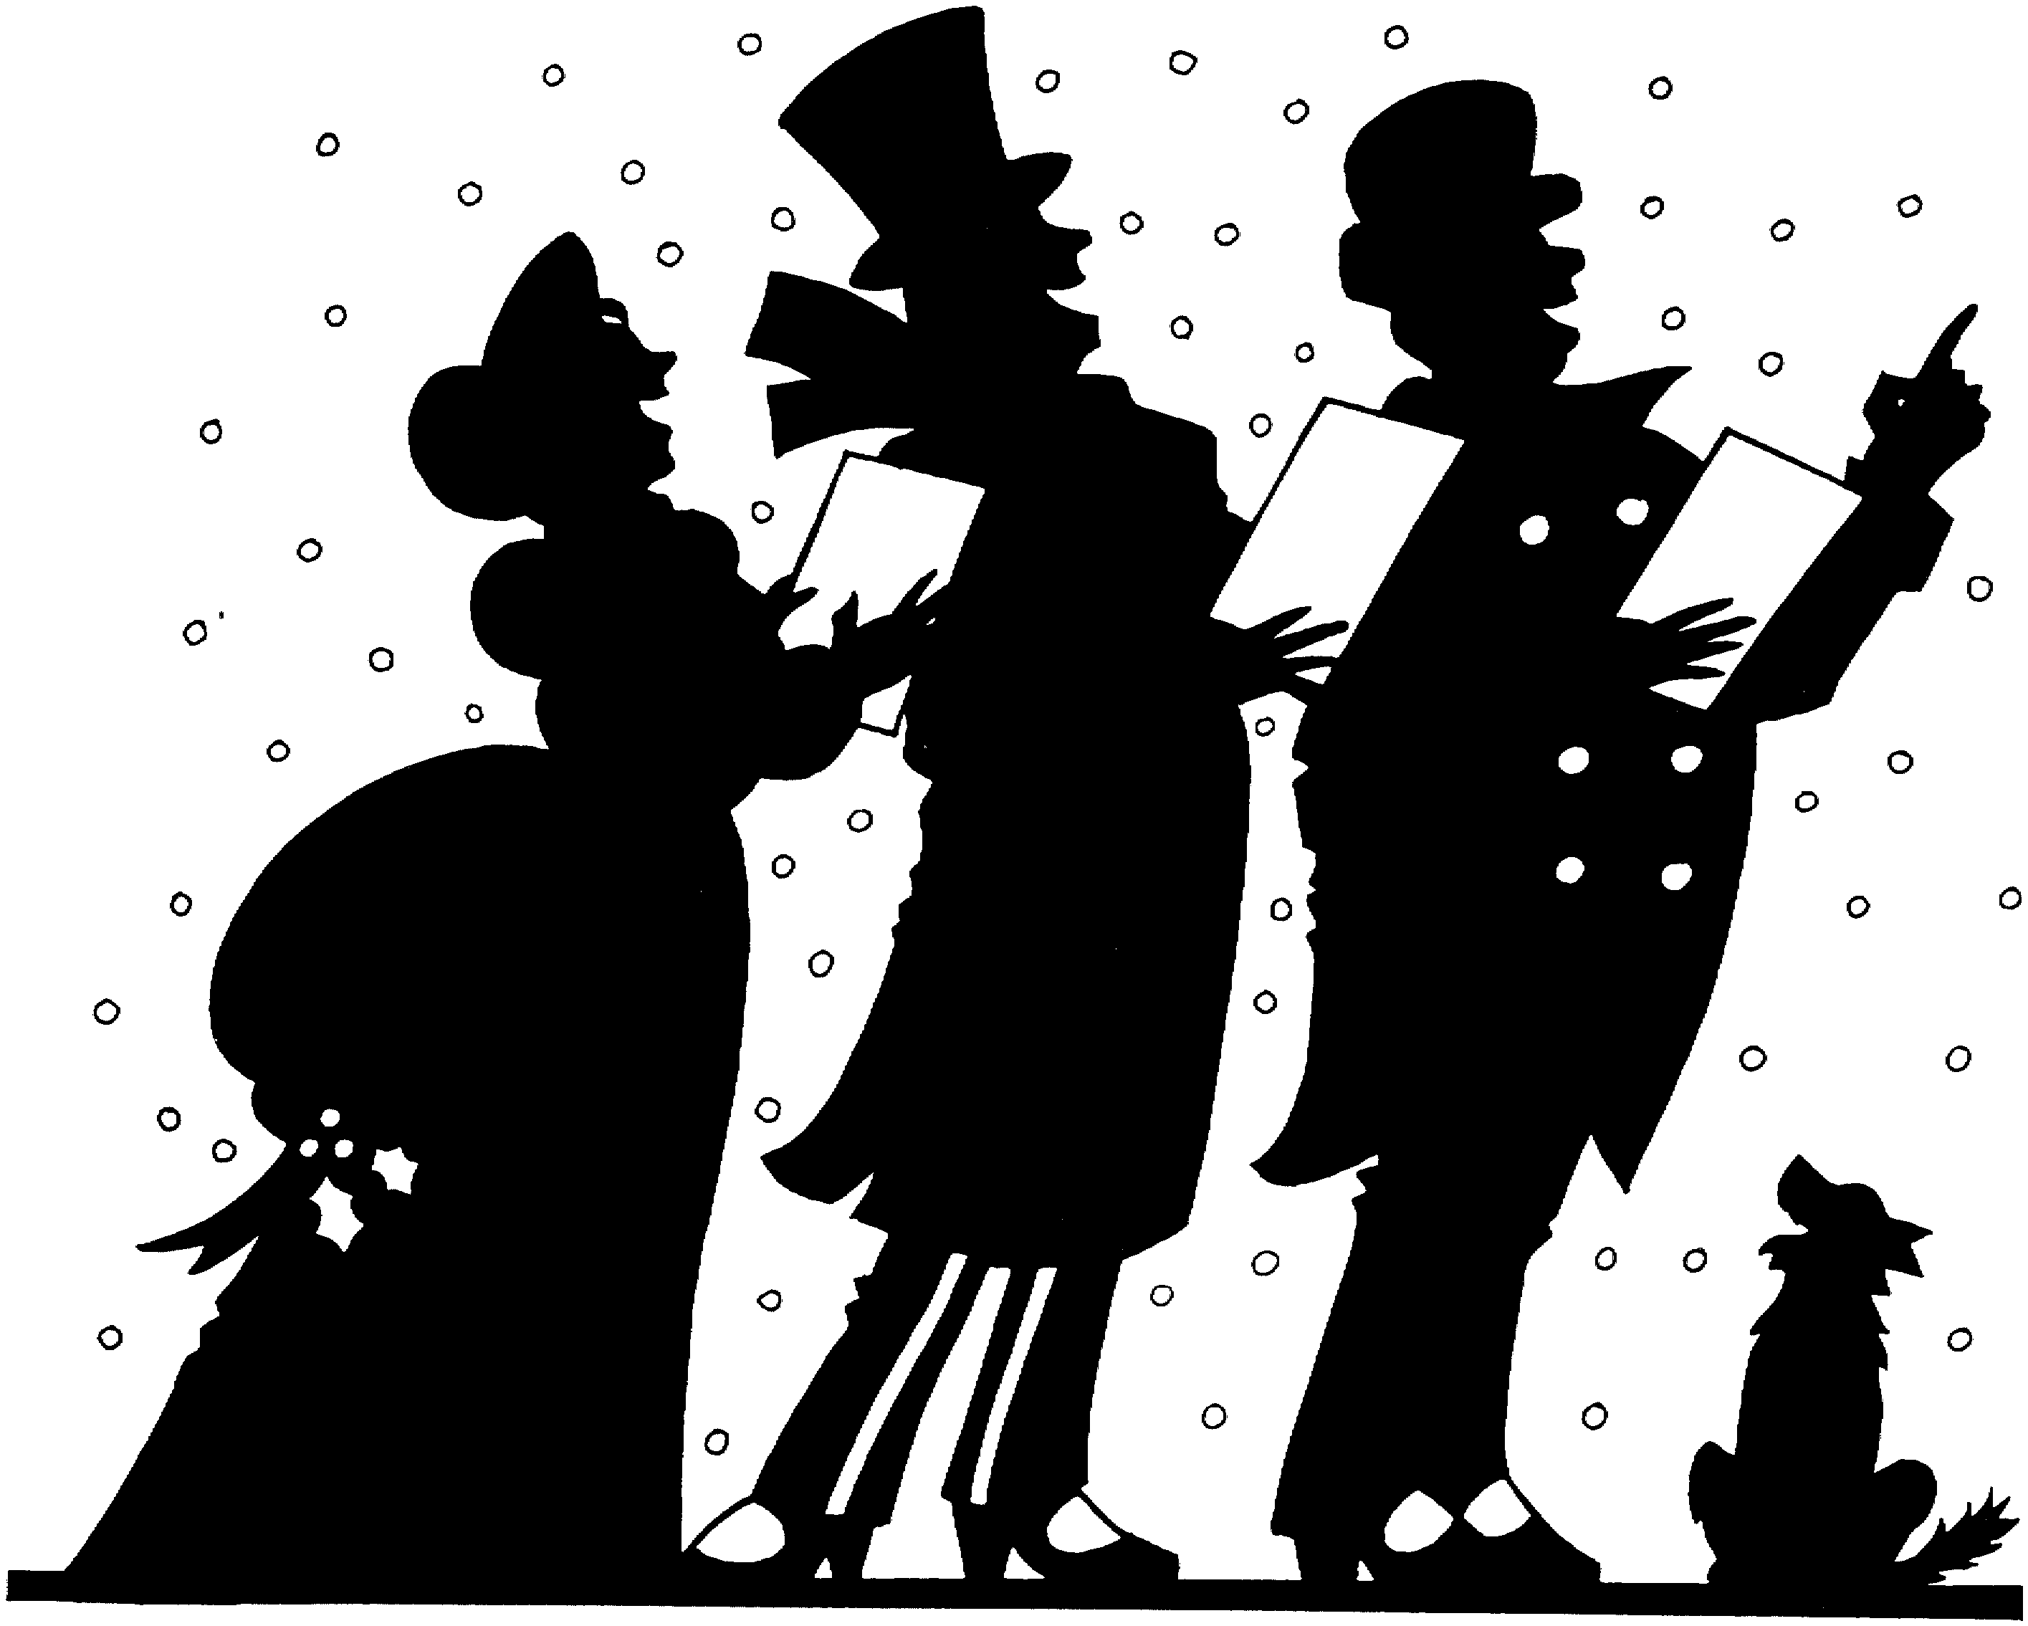 | CAROLS Christmas songs were sung as early as 129 AD. In Middle English carole was a kind of round dance with singing, from Old French carole. Caroling was popular in England until it was banned by the Puritans as being pagan.  This custom probably originated in pagan times to ward off evil spirits. Sometimes a group of musicians takes instruments to the belfry of a local church and lustily play four Christmas carols, one in each direction of the compass. They finish with a joyful peal of the bells, which announces that Christmas has arrived.
Crèche Activity  <>Sing,  "Crèche Flickers Bright Here" (#227 in Hymnal)  "Gather 'Round the Manger" (#229 in Hymnal) | 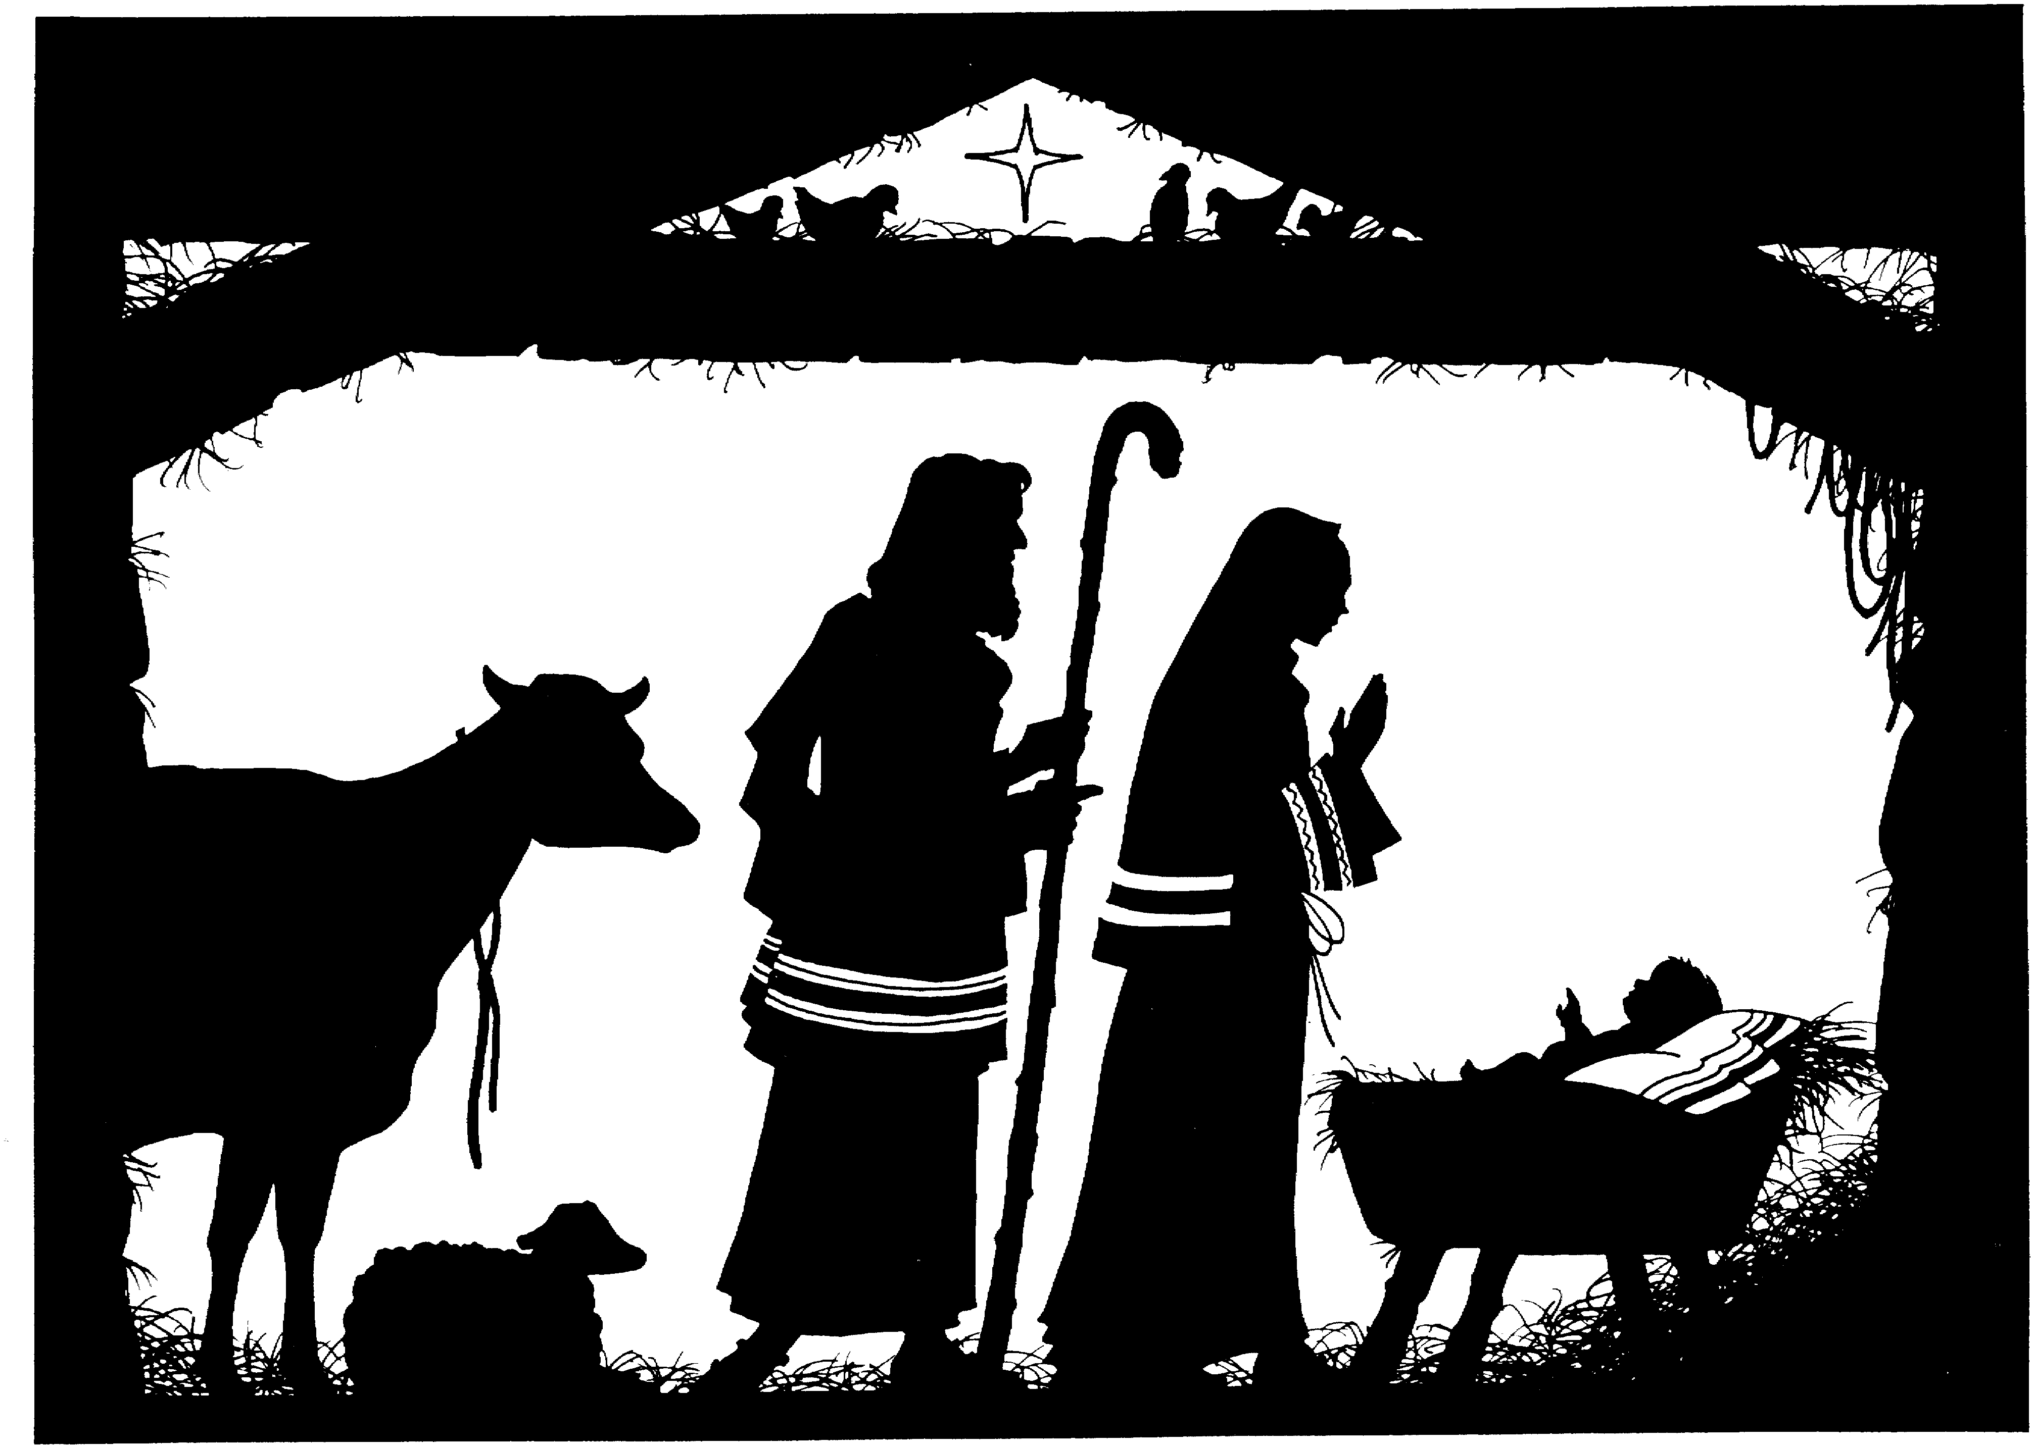 | Crèche. The crèche is the scene in the stable or barn at the time Jesus was born. The main characters in the scene are Mary, Joseph, the baby Jesus. Usually there are some animals, like sheep, possibly some shepherds, and sometimes the three kings or wise men. Crèches come in all sizes. There are small ones that can be hung from the tree or carried in a pocket, and there are big ones, using people and animals, or life size statues.

CHRISTMAS DAY ACTIVITY  <>Greet each other with "Merry Christmas" as soon as you get up, and have a day filled with love and joy.  <>Remember why we celebrate Jesus' birthday. Jesus "went about doing good," and he has been called "the man who changed the world." We celebrate his birth because of his ideals and influence for good. We also celebrate his birth to remind ourselves of the wonder of everyone's birth. | 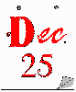 | CHRISTMAS DAY The actual birthday of Jesus is not known. The early Christian leaders put it on December 25, the celebration of the sun god in Rome, as a way of moving people from the old beliefs toward the Christian celebrations. The first mention of the birthday of Jesus was in 354. Most Christian churches on this continent celebrate Dec. 25 as Jesus birthday, but some Christian Churches celebrate it on January 6. By legend, January 6 would have been the time that the kings from the east arrived in Bethlehem to see the baby Jesus. The 12 days of Christmas are the time between the two dates.
FOOD ACTIVITY  <>Make a collage of pictures of different kinds of Christmas foods using pictures from magazines.  <>See how many special Christmas foods you can name.  <>Talk about the menu – list of foods – that you will have in your family this Christmas.  <>Take food items to a food bank or food kitchen. |  | FOOD We have all kinds of special food at Christmas: cakes, pies, cookies, candies. Part of the fun is in preparation, when people in the family work together.  In old societies, hunger was a problem in winter, so that the foods and feasts of celebrations were very important. Sometimes small cakes and cookies and dried fruit and popcorn chains were part of the decorations for the tree.  But if Christmas is the celebration of Jesus' birth, why don't we have a birthday cake?
GIFT ACTIVITY  <>Carols: “Little Drummer Boy?  “What can I Give Him?”  “Good King Wenceslaus”  <>Think about what you can give someone who has special needs this season, such as through programs in the community or church.  <>Guest at Your Table. These boxes are for collection for the Unitarian Universalist Service Committee. Remember this way of giving during this holiday season. | 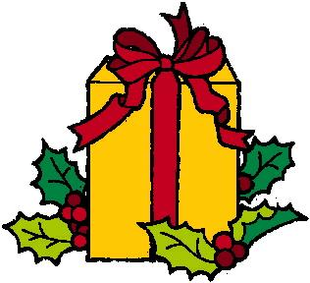 | GIFTS/PRESENTS. There are many celebrations that include for giving gifts: St. Nicholas (Santa Claus), the kings giving gifts to Jesus, the Roman custom of giving gifts of good luck during Saturnalia, the predecessor to Christmas Day.  Gifts are a major part of the Christmas celebration, both the gifts we give and the gifts we get. There are many traditions about giving gifts to the poor or sick or lonely. We spend time making gifts and buying gifts, and wrapping gifts. When we give a special gift, we are giving part of ourselves.

ACTIVITIES FOR THE BIRDS  Make a birdfeeder: Roll a pinecone in peanut butter, then in bird seed. Hang outside. | 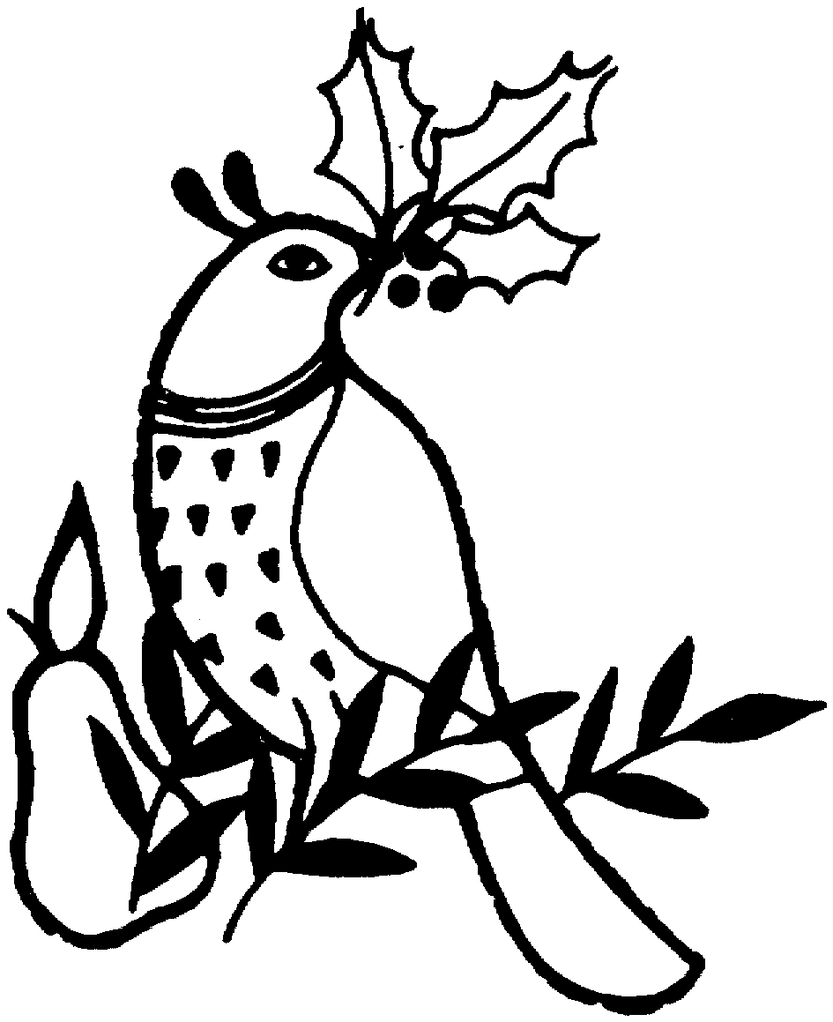 | BIRDS It is the custom in Scandinavia to place a sheaf of grain on top of a tall pole for the birds to eat, or popcorn chains, or even just seeds and bread are placed on a pole and set up outside where the birds are known to congregate. This is done on Christmas Eve or Christmas Day. The sight and sound of outdoor festivity at the bird’s Christmas tree adds to the indoor celebration of people.  Birds are also part of the fun story of the Twelve Days of Christmas, with the "partridge in a pear tree" and swans and hens, to name a few.
HOLLY ACTIVITY  <>Sing carols about holly and decorating, such as  “The Holly and the Ivy”  “Deck the Halls with Boughs of Holly” (#235 in Hymnal) | 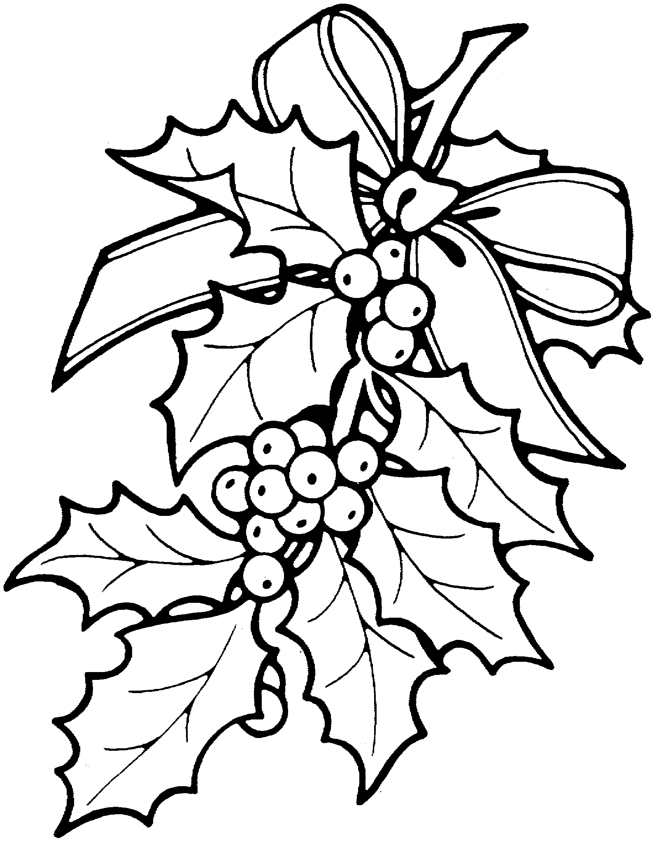 | HOLLY On the night that Jesus was born, it is said that fruit appeared on trees, even in cold areas. Maybe the red berries of England and France reminded people of this story. Early Christians in Rome were not allowed to celebrate Christmas. But Romans celebrated the Saturnalia festival, using holly. The Christians used holly to disguise their Christmas celebration.  The bright colors of the holly made it a natural sign of rebirth and life in the winter of northern Europe. In late December, people place holly and other evergreens around inside of their homes as a promise that the sun will return.
KINGS OR MAGI OR WISE MEN ACTIVITY  <>Read Matthew 2:1-12  <>Sing  "We Three Kings of Orient Are" (#259 in Hymnal)  "On This Day Everywhere (#249 in Hymnal) | 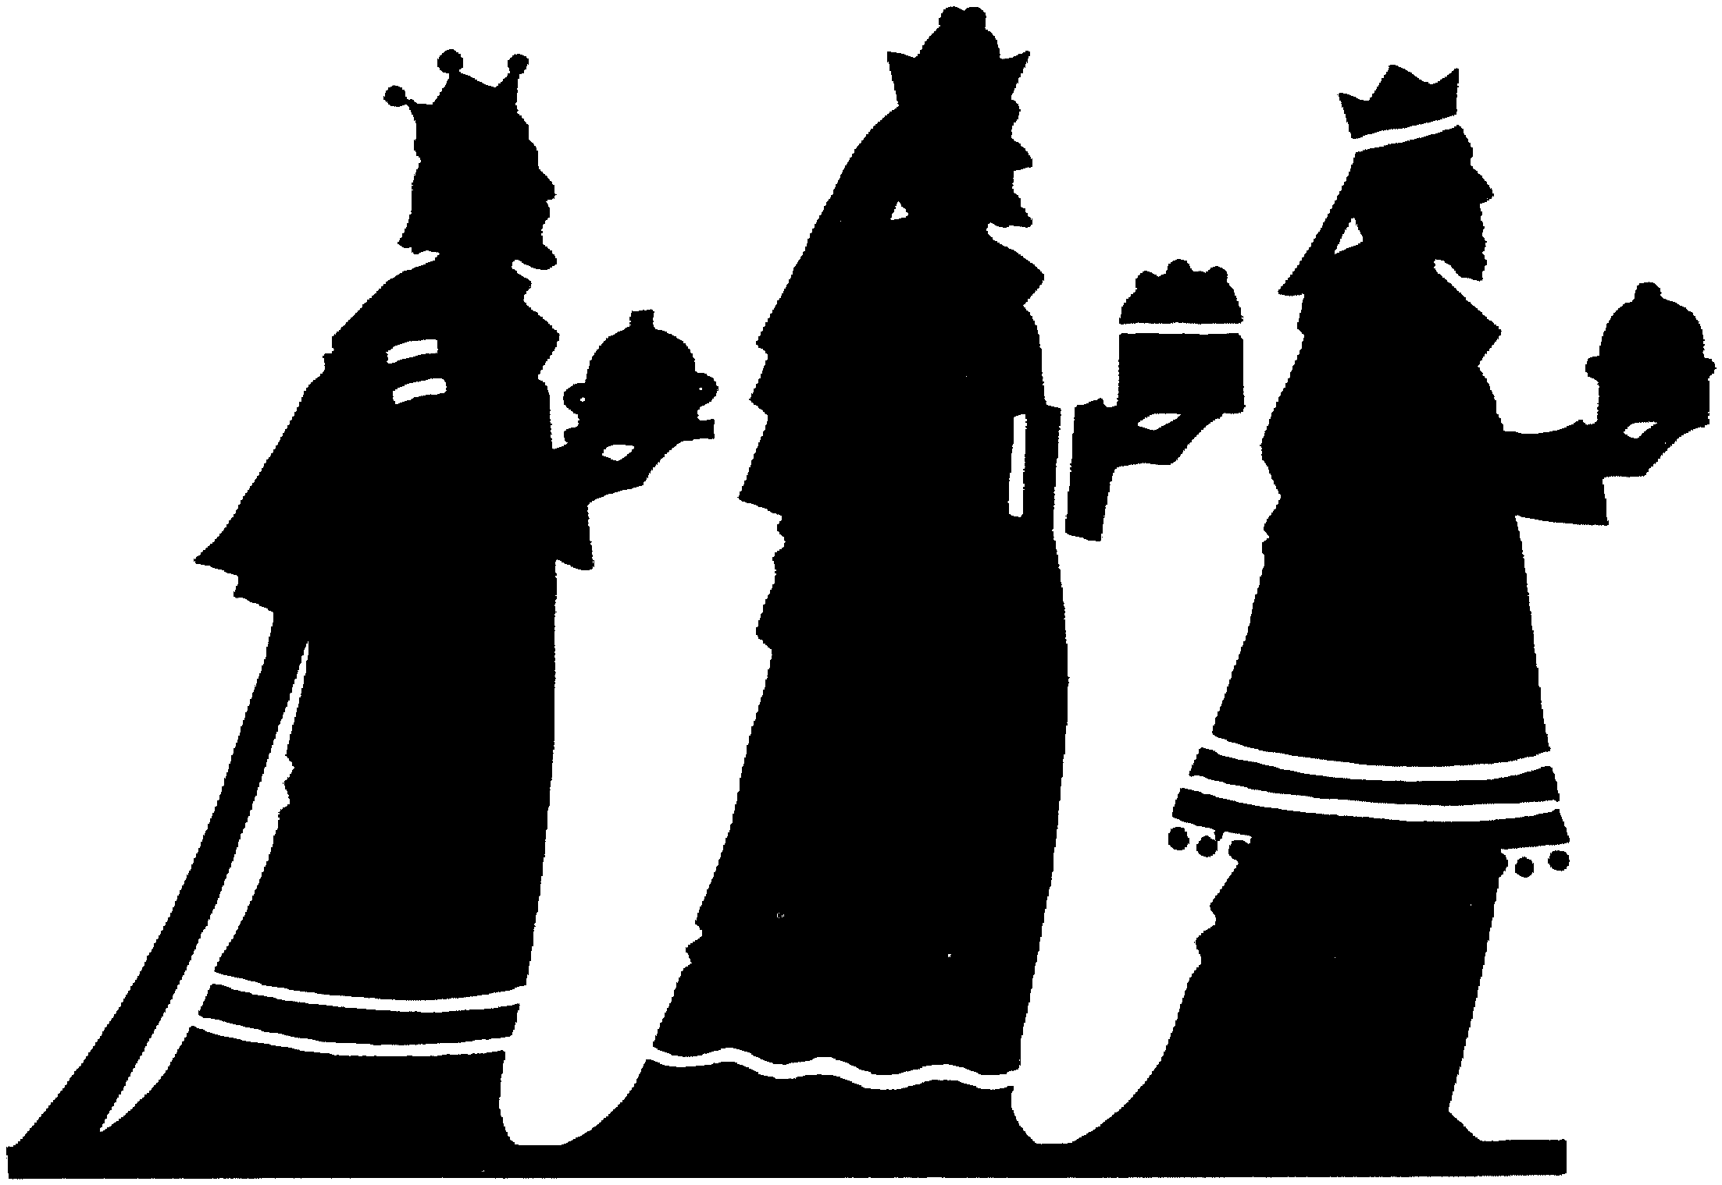 | KINGS OR MAGI OR WISE MEN The Christmas story includes three visitors who came to see the baby Jesus. The legend states that the wise men were from Persia (Iran) and may have been priests of an eastern religion. The pilgrimage had significance for them, as it took a long time for them to travel the distance.  Maybe the story of the kings has been included to show the importance of the person of Jesus. The gifts that the kings gave him were like wishes or to foretold his life: gold for riches, frankincense (an incense used in religious ritual), and myrrh (used in perfume, used by rich people).

MISTLETOE ACTIVITY.  Mistletoe (real or artificial) can be hung for decoration. For the holiday, kiss or shake hands in peace whenever you pass someone under the mistletoe. | 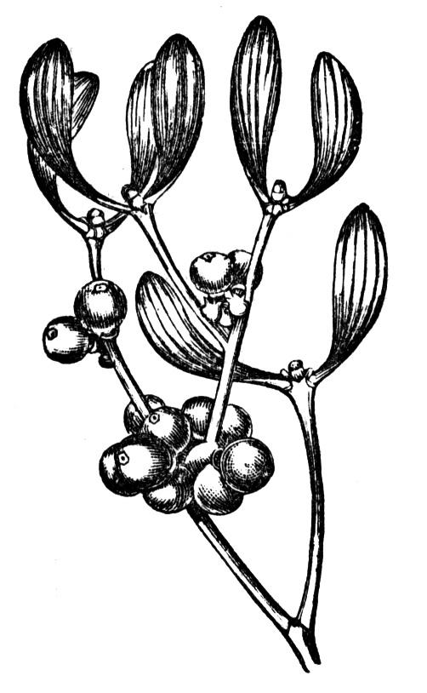 | MISTLETOE Mistletoe was supposed to have healing powers. It was also a symbol of peace and enemies would stand beneath a spray of the plant to make peace compacts. Sometimes the peace would be sealed with a kiss.  It became tradition that a kiss beneath a mistletoe branch held good luck. For each kiss, a berry was removed. When all of the berries were gone, that piece of mistletoe lost its magic.
HANAKKAH ACTIVITY | 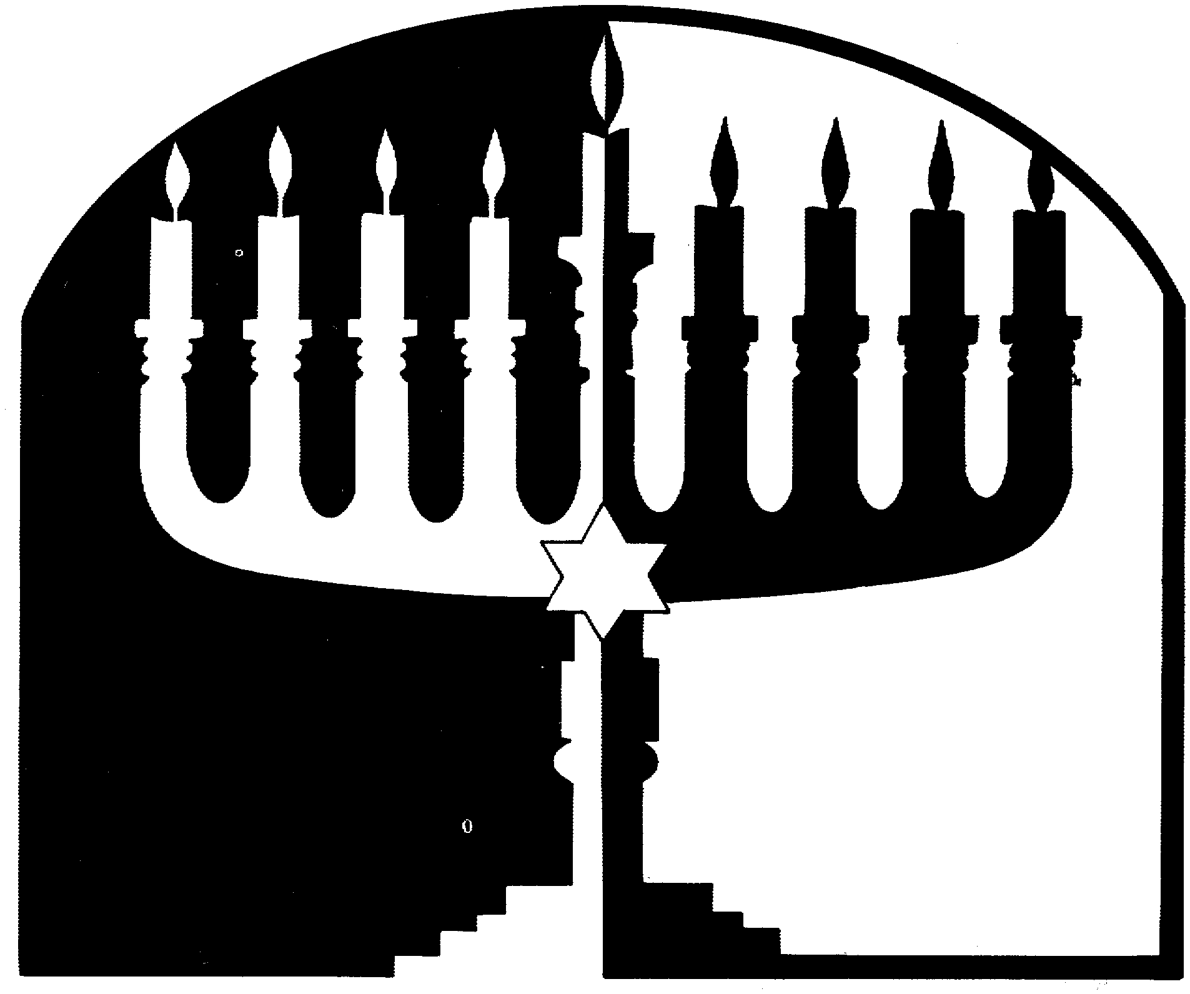 | HANAKKUH Hanukkah is the Jewish festival of lights that commemorates the rededication of the Temple in Jerusalem, their most important place of worship, after wars in 165 BC (before Jesus lived). There was enough oil for the temple lamps for only one day, but the oil actually lasted for eight days.  The candlestick for Hanakkah holds 8 candles. There is a taller one in the center that is used to light the others, lighting an additional candle each days of the celebration.
PLUM PUDDING  <>Make a special food for Christmas.  <>Churches or other groups may make plum pudding for sale, or get a recipe and make your own. (Takes time) |  | PLUM PUDDING The first plum puddings were made around 1670. Plum puddings do not contain any plums. They were a stiffened form of earlier plum porridge, with added lumps of meat, dried fruits (raisins, currants), rum and brandy, butter, sugar, eggs and many spices. They were made in large copper kettles several weeks before Christmas. People took turns stirring. A coin, thimble, button and ring were mixed into the pudding, and found when the pudding was eaten. The coin meant wealth, the button or the thimble meant that the person would not get married, and the ring meant that the person would get married.

POINSETTA ACTIVITIES  <>Give a plant to someone, or donate one for decoration of the church for Christmas and Christmas Eve services. |  | POINSETTA In Mexican legend, a small boy had no gift to bring to church on Christmas. As he prayed, a plant grew at his feet, bright red and green. This plant became known as the “Flower of the Holy Night.”  Between 1825 and 1829, Dr. Joel Roberts Poinsett was the American ambassador to Mexico. He brought the plant back to his home in South Carolina. It became a popular Christmas plant and was named after him. Actually, the “flowers” are really leaves! We now have different colors – red, white, pink.
SANTA CLAUS, ST. NICHOLAS ACTIVITY  <>Take a piece of cloth, put some small things in it – beads, buttons, pebbles – and tie the corners to make a gift bag of toys. Use the yarn to hang the bag. | 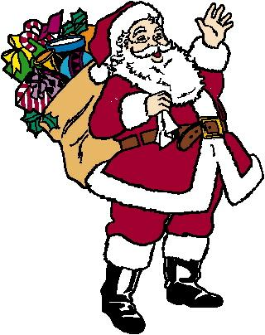 | SANTA CLAUS, ST. NICHOLAS St. Nicholas’ Day is celebrated on December 6. He was the Bishop of Myra, who did good things in secretly. He would disguise himself by wearing a red robe and white whiskers. He died on December 6, 343. As this was near the Winter Solstace, he became the “patron sait” of the season.  In 1822, Clement Clarke Moore, a Unitarian, wrote a poem about St. Nicholas for his children.
SHEEP/SHEPHERD ACTVITY  <>Sing “While Shepherds Watched Their Flocks by Night” or “The First Nowell" *(#237 in Hymnal) or "Whence, O Shepherd Maiden?" (#258 in Hymnal)  "Silent Night" (#251 in Hymnal)  <>Read Luke 2-20. | 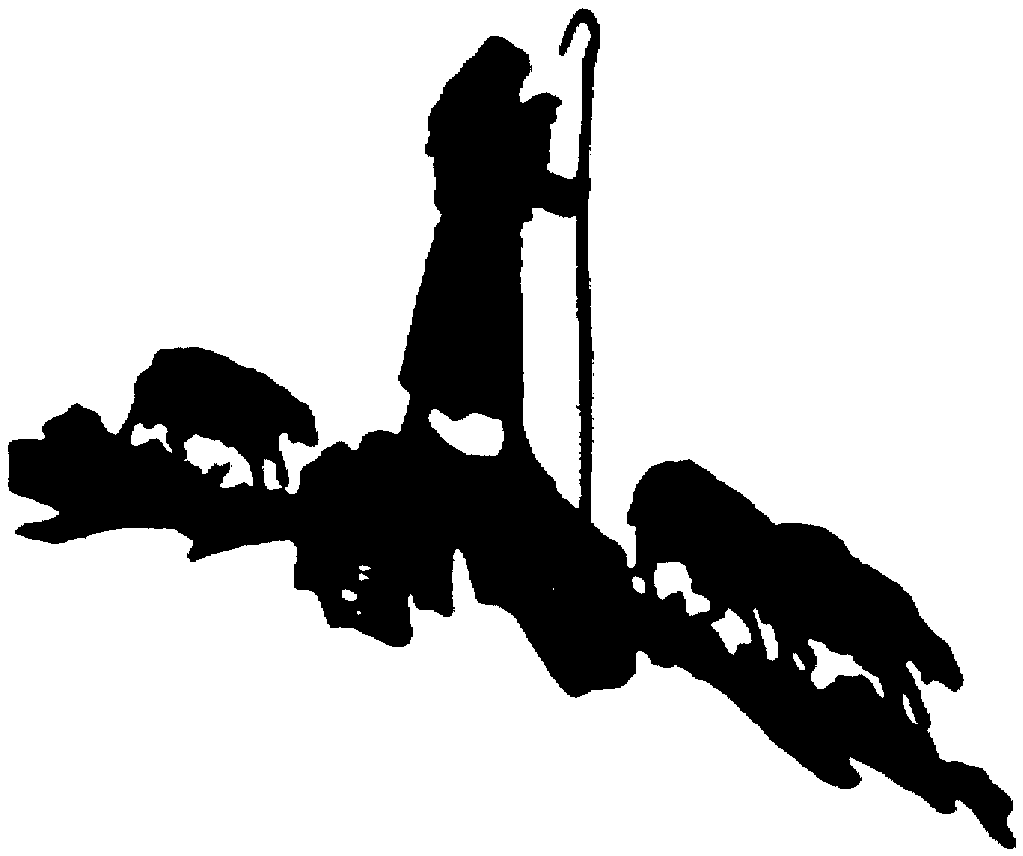 | SHEEP/SHEPHERDS Sheep and other animals are part of the Christmas tradition. Sheep were said to have been in the stable when Jesus was born. The shepherds, who were in the fields, heard the angels sing about the birth of Jesus. The shepherds were considered to be common people, not religious or political leaders. Their inclusion in the story showed that the birth of Jesus was for everyone.

STOCKINGS ACTIVITY  <>Make a stocking by taking one of your own socks. Glue or sew on Christmas bells, balls, pinecones. Put a nice note foe Santa, and something to eat out on Christmas Eve.  <>Make a stocking for someone else. | 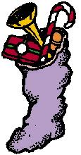 | STOCKINGS Socks and shoes are used to collect things from St. Nicholas or Santa Claus. In Spain, Holland and Belgium, children fill their shoes with carrots and hay fro St. Nick’s white horse. We may leave cookies for Santa and something for the reindeer!. St. Nick is said to leave coal for children who have not been good and toys for those who have been good. By legend, a girl hung her stockings to dry and St. Nick left her gold.
STORIES ACTIVITIES  <>Create a story and write it down or tell someone.  <>Collect Christmas stories from your family and friends—their favorite stories or stories of things that have happened to them around Christmas.  <>Many carols give parts of the Christmas Story, but "Once in Royal David's City" (#228) gives the total story. | 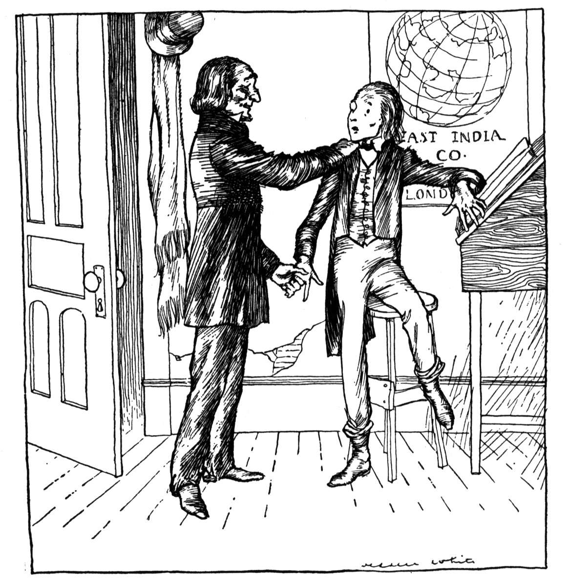 | STORIES Many stories have been written and told about special things that happen at Christmas. A famous story is “Christmas Carol” by Charles Dickens, who was an English Unitarian. Stories may tell about magical things happening, from angels appearing to animals talking. There are stories about the good things that people do at Christmas to help other people.  The story of the birth of Jesus is just that -- a story. It was told after people started following Jesus, and then was written down by various people who told different parts of the story. See Matthew and Luke.
STAR ACTIVITIES  <>Color the picture or put star stickers on the tag.  <>Make a star, with either 5 points (traditional star), 6 points (Star of David) or as many points as you want! Hang it up for decoration.  <>Sing  "There's a Star in the East" (#255 in Hymnal)  "Within the Shining of a Star" (#238 in Hymnal) |  | STAR Stars were used as decorations to symbolize the star that lead the three kings or wisemen to Bethlehem to see the baby Jesus. Some people put a star on the top of the Christmas tree. The light from candles remind people of the light of the star. Stars are part of the tradition of the Jews, with the Star of David as their symbol.  Variously descried of the supernova or a conjunction of planets, there is discussion about when it actually occurred. The year 7 BC is probably the true birth year of Jesus.

TREE ACTIVITY  Decorate your own tree. Make a new ornament for each person in the family each year. Then the tree becomes a tree of memories.  Decorations include changes of colored construction paper strips, popcorn.  Sing,  "O Christmas Tree" | 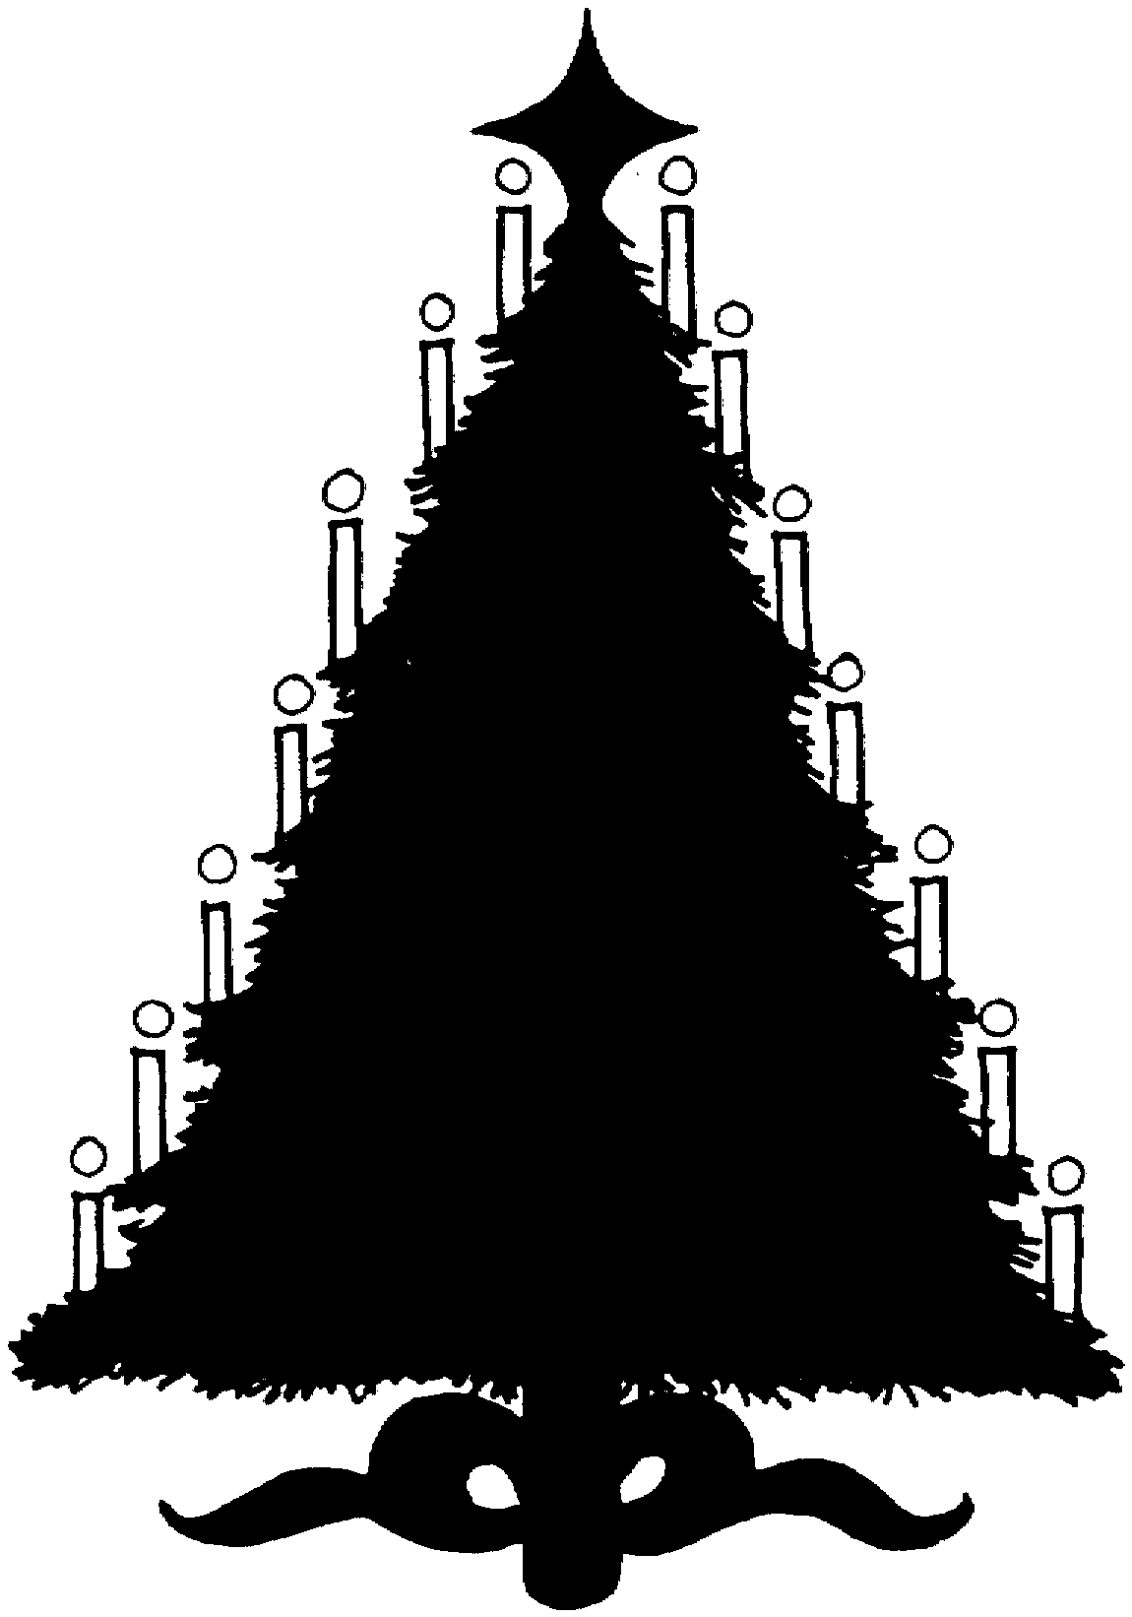 | TREE Christmas trees, undecorated, go back to the 700’s in Germany. Martin Luther, a religious reformer in the 1500’s, saw stars shining through the branches of evergreen trees and put candles on a tree in his house.  In a German story, children gave a visitor food and shelter. The visitor (Jesus), said that their tree would have ripe fruit at Christmas, so we hang balls and bright things on trees. Rev. Charles Follen introduced the Christmas tree to the Unitarian congregation in Lexington, Massachusetts. Pennsylvania Dutch had used trees in their celebration a hundred years earlier.
WRAPPING ACTIVITY  <>As you wrap Christmas gifts, take a piece of paper and add it to a collage, or collection of paper glued onto a piece of construction paper. The collage can be hung up for decoration.  <>Add a piece of wrapping paper to this tag.  <>Wrap gifts in layers, with a note to the person in each layer. This makes the gift more personal. | Add a piece of Christmas wrapping paper. | WRAPPING In Denmark, packages are wrapped so that you cannot tell what is inside. There were several layers of paper, each one with a different name on it. The person whose name is on the layer unwraps that layer, until the present is reached. Sometimes the package contains a card telling where the gift is hidden.
WREATH ACTIVITIES  Make a wreath from pieces of evergreen trees by bending branches into a circle and using string or wire to hold in place. Decorate with ribbon, bows, cones, ornaments. | 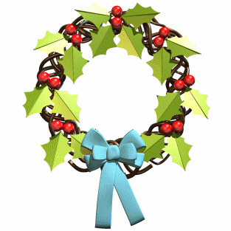 | WREATHS A wreath suggests a crown and seems to have been used first in Greece to indicate honor and peace. Legend says that little Jesus, carrying a fir branch, wanders on Christmas Eve seeking homes where he is remembered and loved. Whenever he finds a home with evergreen on the door or window, he touches it for a blessing. In England, Advent wreaths had four candles, one for each week of Advent, the time to get ready for Christmas.  We light the candles each week for Faith, Hope, Love and Jo, and consider the wreath itself to symbolize Patience.

YULE LOG ACTIVIES  <>Color the log on the tag.  <>Tape a small stick to the tag to represent the yule log.  <>If you have a fireplace, find a big log to save to burn on Christmas Day. | 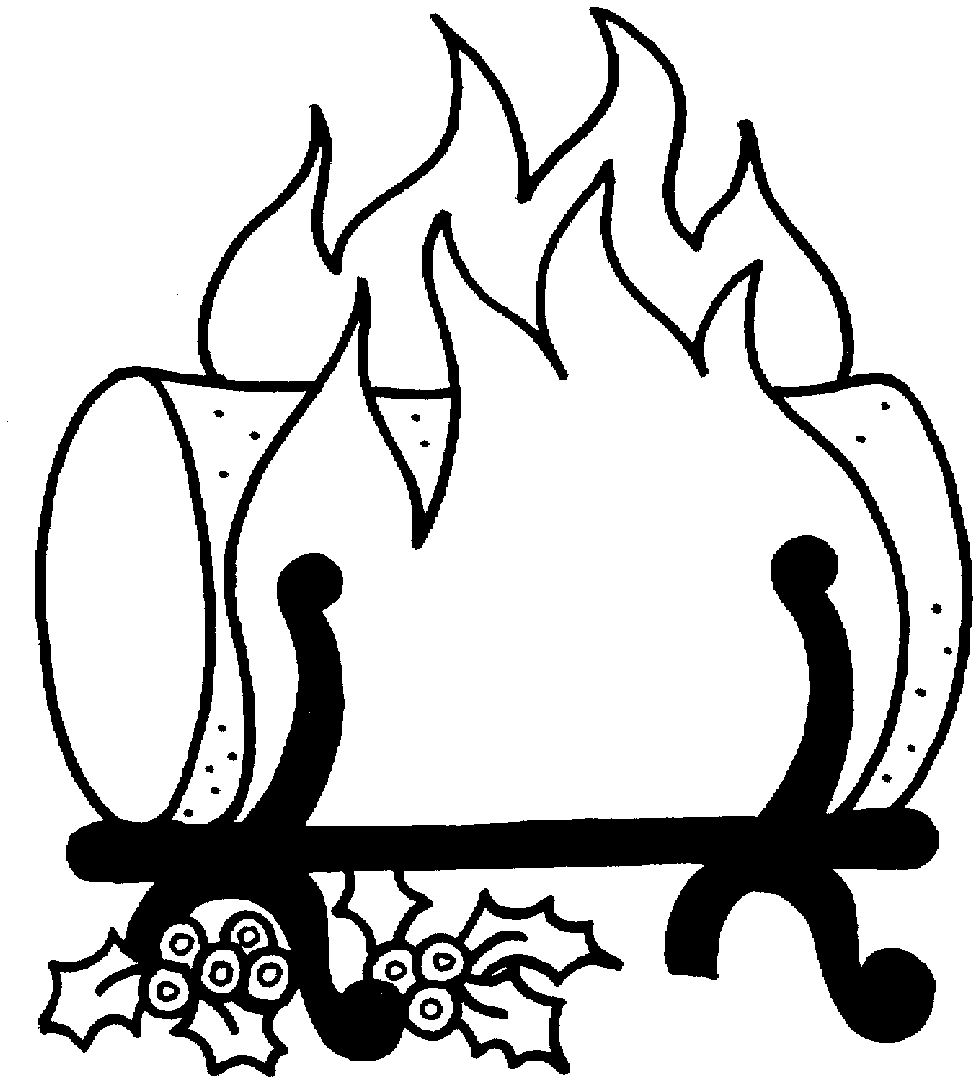 | YULE LOG The yule log may have started in Scandinavia and brought to the British Isles. It was a big event to go out and choose the yule log. The log was burned, hopefully for the 12 days of Christmas (Dec. 25-Jan.6) and the charred remains were saved to use as kindling for the following year's fire. The remains were also seen as a protection for the house against lightning and fire.  The log should be carried into the house by the youngest and oldest in a family. There were many ideas about the good or bad luck that the log brought.

Advent Calendar

In this calendar, there is a different symbol for each day.

- Most Advent Calendars actually start on December 1 and go until Christmas. This Calendar has enough parts to start four weeks before Christmas.

- There are "tags" that tell something about the symbols. They are arranged alphabetically. Cut the tags on the horizontal lines on the pages of symbols.
Fold each tag so that the picture and description are on the outside. Open the tag for the activities that can be done with that symbol. Consider a tag each day, in any order.

May the symbolism of the season increase our understanding of the wonder and mystery that surrounds us. And may the rebirth and recreation that the Christmas Story portrays be part of our personal spiritual experience of this Holiday Season.

References:
Celebrating Christmas: An Anthology, Carl Seaburg, Unitarian Universalist Ministers' Association, 1983
Singing the Living Tradition, UU Hymnal
Book of Holidays Around the World, Alice van Straalen, New York: E. P. Dutton, 1986

Rev. Helen Zidowecki, 32 Stevenstown Road, Litchfield, Maine 04350; 207-582-5308, www.hzmre.com (hzmre@hzmre.com

